**free command:**

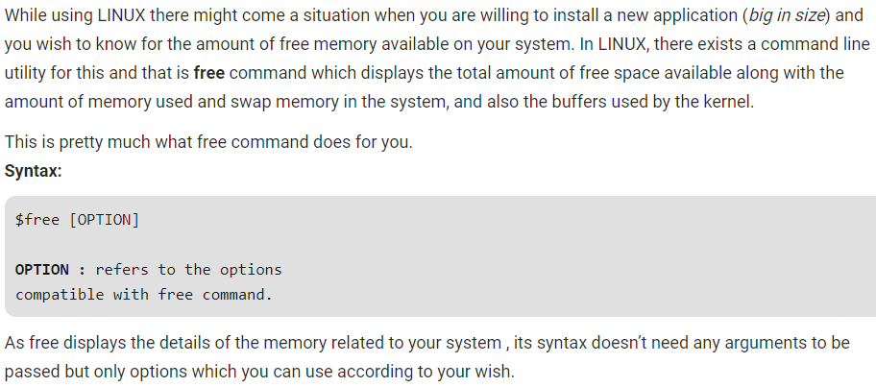

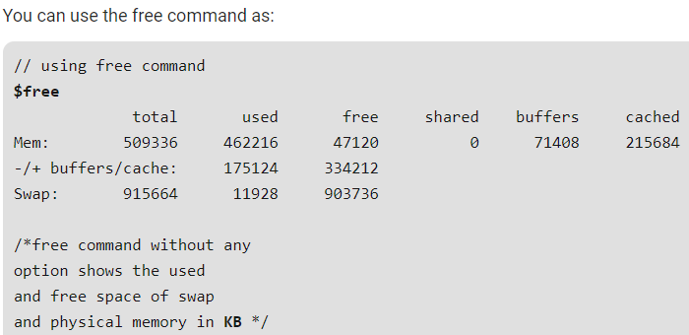

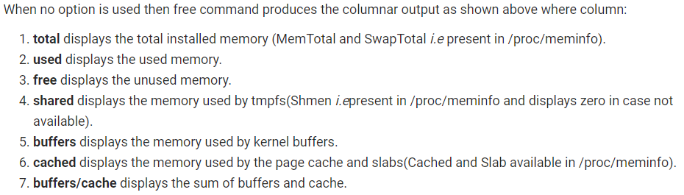

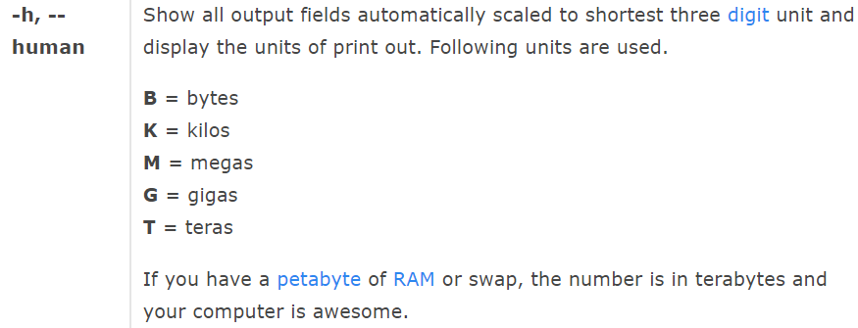

**Options:**

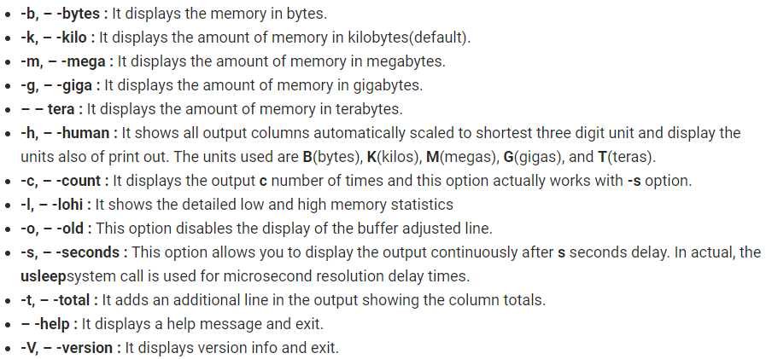

**Examples:**

**Using -b:** It just displays the output in unit bytes.

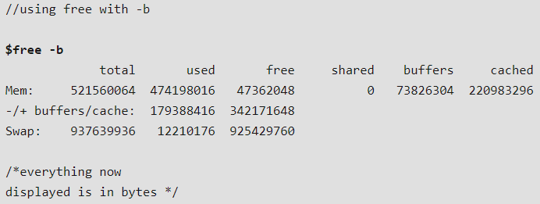

**Using -k:** This option displays the result in kilobytes.

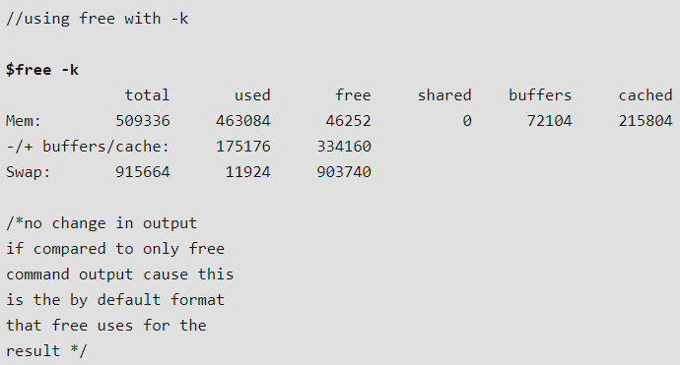

**Using -m:** This option displays the result in megabytes.

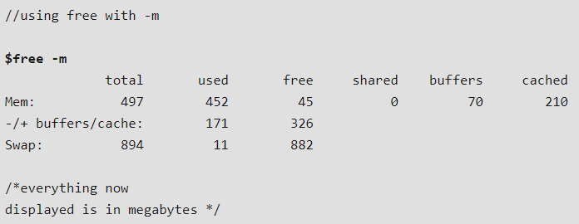

**using -g:** This option displays the result in gigabytes.

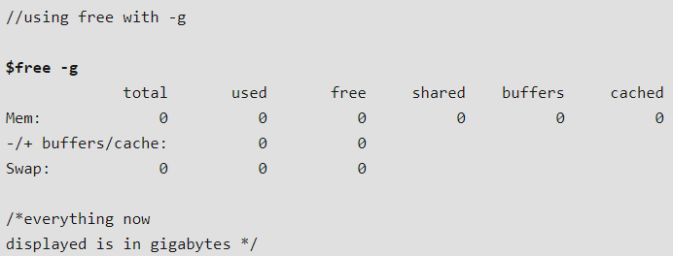

**Using -t (total):** This option displays an additional line containing the total of the total, used and free columns.

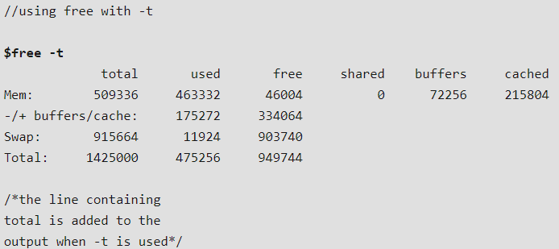

**Using -s and -o:** This option allows you to display the output of free command after a set time gap given by the user. This option requires a numeric value to be passed with it that is treated as the number of seconds after which the output will be displayed.

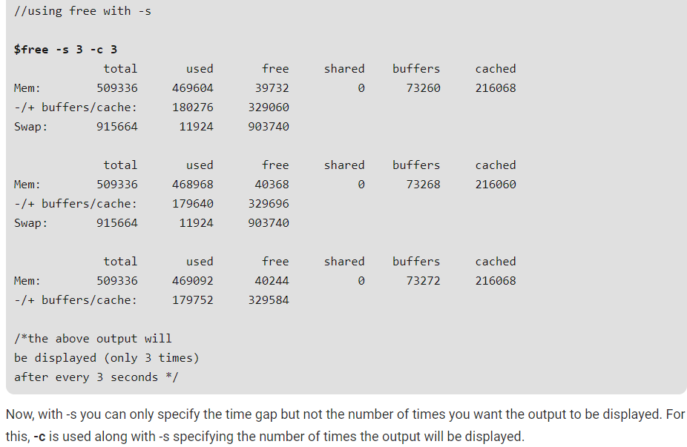

**Using -o:** This option makes the buffer/cache line go away from the output as shown below.

